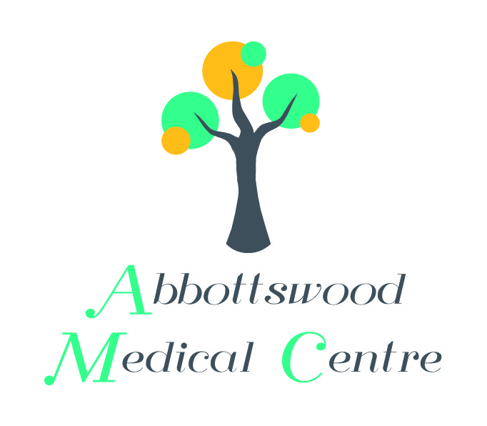
ABBOTTSWOOD MEDICAL CENTRE
DEFFORD ROAD, PERSHORE
WR10 1HZ
TELEPHONE : 01386 552424

CONSENT FORM FOR AUTOMATED COLLECTIONS.
- No more queuing to collect your prescription
- Collect day or night 24/7, weekends and bank holidays
- Free, easy parking by the Prescription Collection Point
- You will receive an SMS text when your prescription is ready for collection- No more wasted journeys

Name

Address

Postcode
Telephone Number
Mobile Number *
Email address (if available)

Are you exempt from paying prescription charges? Yes No
A | is 60 years of age or over or is under 16 years of age.
B | is 16, 17 or 18 years of age and is in full time education
D | Maternity Exemption Certificate.
E | Medical Exemption Certificate
F | Prescription Prepayment Certificate
G | Prescription Exemption Certificate issued by MOD.
L | HC2 (full help) Certificate
H | Income support or income related employment and support allowance
K | Income-based jobseekers allowance
M | Tax Credit Exemption Certificate
S | Pension Credit Guarantee Credit (including partners)
U | Universal Credit

*It is essential that you provide your mobile number as we will be required to send you an SMS text message with your unique collection PIN number each time you have a prescription to collect.

Please note: There may be some medicines which may not be suitable to be collected from the collection point. These will need to be collected in person from Abbottswood Dispensary during normal working hours.

Signed……………………………………………………… Date………/………./………..

Print name……………………………………………….

